
École Barrhead Elementary School
Supply List 2026-2027
1C- Mrs. Keri Messmer
😊 I am SO excited to have your child in my class in the fall!
😊 Please bring all supplies to the
Open House will be on Thursday, August 27 from 3:00 - 6:00 or to the first day of school
😊All items need to be labeled with your child’s name!
😊Sharpened pencils and pencil crayons would be greatly appreciated!
😊 Place extra supplies in a large Ziploc bag with your child’s name.
These will be kept in the classroom and supplies will be restocked as needed.

■ 2 pencil boxes
■ 1 package wax crayons
■ 1 package pencil crayons
■ 1 package thin markers
■ 1 package thick markers
■ 12 Ticonderoga “My First Tri-Write” pencils or Staedtler “My First Norica” Jumbo pencils
or 24 regular HB #2 pencils
■ 3 Duotangs (any color, with 3 prongs)
■ 3 Hilroy exercise book
- ½ plain - ½ lined -72 pages
■ 3 80page coil scribbler
■ 6 UHU glue sticks 21 g. (74 oz.)
■ 1 pair of scissors
■ 2 erasers
■ 2 highlighters
■ 6 large EXPO brand whiteboard markers
■ 6 thin EXPO brand whiteboard markers
■ 1 watercolour set with brush
■ 1- 1-inch binder
■ 1 set of headphones
■ 1 box Kleenex
■ 1 bag of spoons and forks
■ extra set of clothes to keep at school
■ 1 bottle of hand soap
■ 1 package of ziploc bags (sandwich and large size)
■ 1 FULL-SIZED backpack
■ Inside shoes (gym runners without tie-up laces)
■ 1 package of wipes
■ 1 bottle of white glue (120ml)
■ 1 Package of laminating sheets
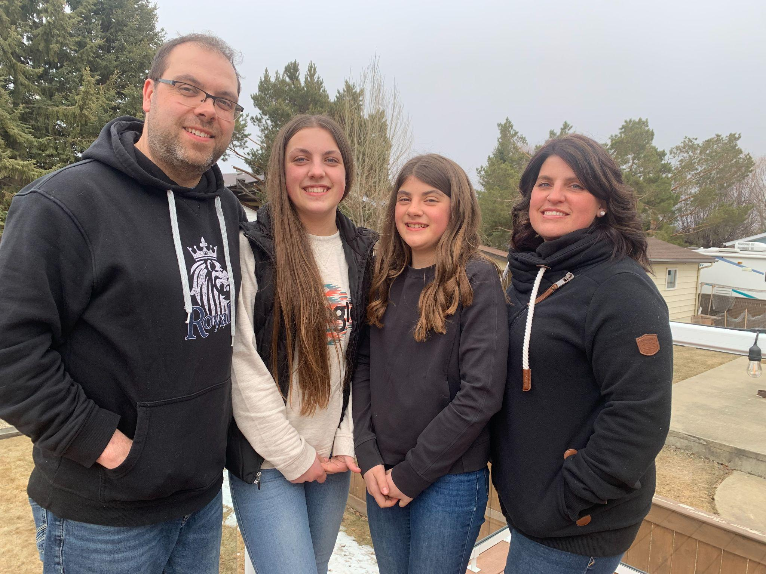
Hi GRADE 1 Students and Parents
My name is Mrs. Keri Messmer. I am excited to have you in my class!
I love being outside, going camping, hiking and gardening. We have added 2 sheep, 6 chickens and 3 horses to our already crazy house of a husband, 2 teenagers, 4 cats and a dog!
If you have any questions please send me an email keri.messmer@pembinahills.ca
