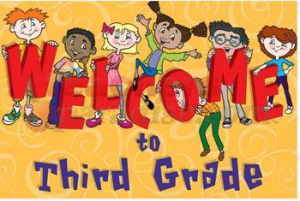
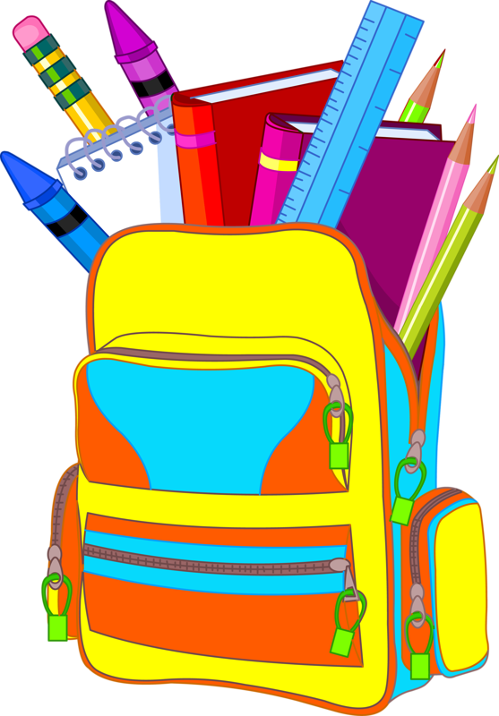
Barrhead Elementary School
Grade 3C – Mrs. Starman
Supply List – 2023/24

- $5.00 (for the teacher to purchase duo tangs and scribblers; this will be included in student fees to be paid online in September)
- Sketchbook (dollar store is fine)
- 1 Yellow Highlighter
- 1 Black Sharpie
- 1 Black Fine Liner (not fine tip sharpies, but a fine liner)
- 4 low odor erasable Expo whiteboard markers (no eraser needed)
- 30 pencils (please buy Staedtler, Ticonderoga- no other brands because they do not last).
- 1 good pencil sharpener (with enclosure)
- 1 pair of Fiskar pointed tip scissors
- 5 white erasers
- 1 pkg pencil crayons (US or Canadian made)
- 1 pkg colored felt markers
- 1 pkg wax crayons
- 5 large glue sticks
- 1 large boxes of Kleenex
- 2 pencil boxes (one box to keep pencils, glue, scissors in and one box to keep crayons and pencil crayons organized)
- Headphones or earbuds for computers (put in a labeled Ziploc bag)
- Lysol wipes (2 large containers) – Lysol brand please NOT Clorox
- Inside Shoes (label with your child’s name)
- 1 box of large ziploc OR sandwich size ziploc bags
- 1 pkg of plastic spoons OR forks

- Rulers will be supplied to students
Please ensure that all the students bring all their supplies for the first day of school. Please put your child’s name on all of their supplies/belongings.

Pencils and pencil crayons should be sharpened. Thank you! The extra supplies will be stored in the classroom and given out as needed. The supplies left over will be returned at the end of the year. I look forward to meeting you on Monday, August 28 from 3:00 to 5:00 at the Open House!

Mrs. Starman

