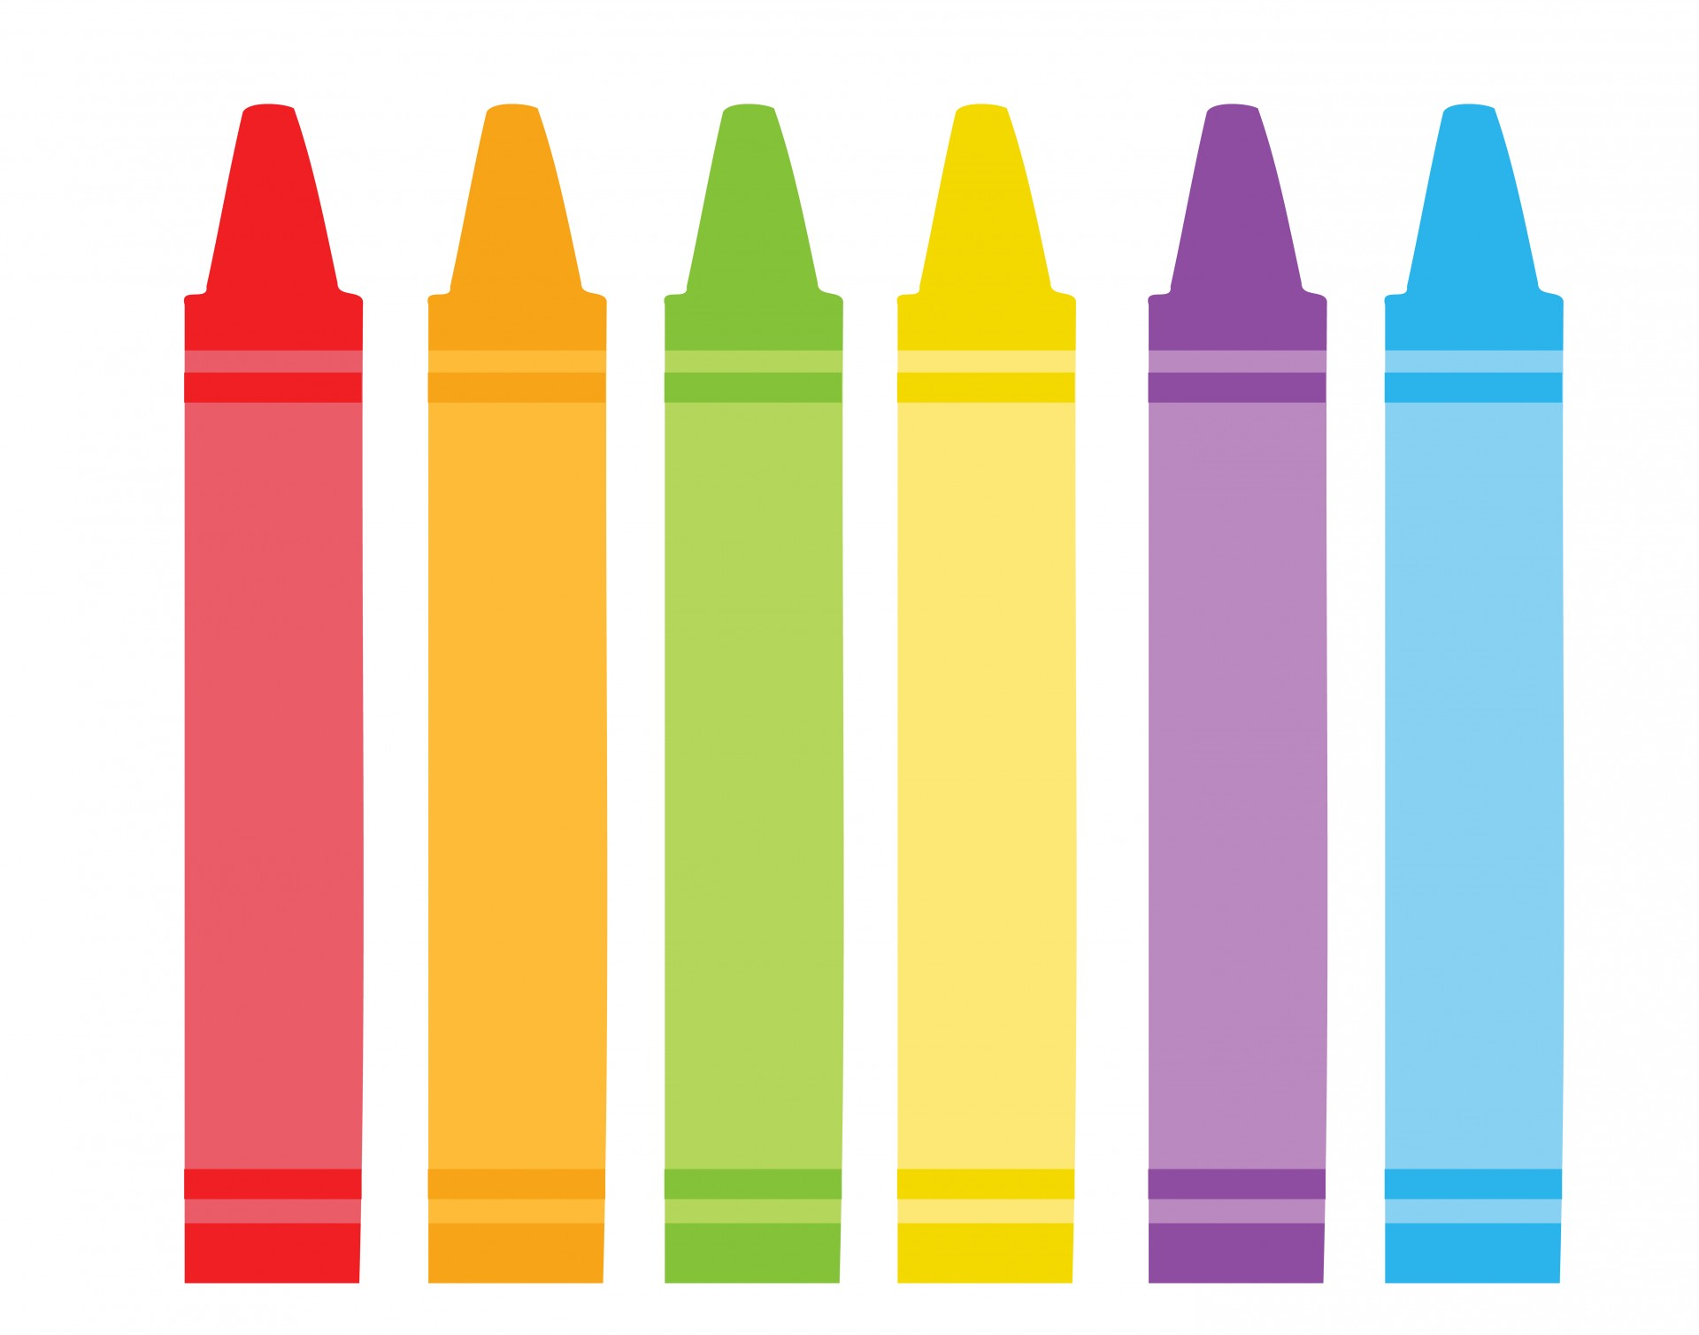
Barrhead Elementary School
Supply List 2023-2024
1C - Mrs.Messmer
😊 I am SO excited to have your child in our class in the fall!
😊 Please send all supplies to the Open House will be on
Monday August 28 from 3:00 - 5:00. or to the first day of school
😊All items need to be labeled with your child’s name!
😊Sharpened pencils and pencil crayons would be greatly appreciated!
😊 Place extra supplies in a large Ziploc bag with your child’s name.
These will be kept in the classroom and supplies will be restored as needed.

■ 2 pencil boxes
■ 1 package wax crayons
■ 1 package pencil crayons
■ 1 package thin markers
■ 1 package thick markers
■ 12 Ticonderoga “My First Tri-Write” pencils or Staedtler “My First Norica” Jumbo pencils
or 24 regular HB #2 pencils
■ 2 Duotangs (any color, with 3 prongs)
■ 3 Hilroy exercise book
- ½ plain - ½ lined -72 pages
■ 5 UHU glue sticks 21 g. (74 oz.)
■ 1 Bottle of white school glue (120 ml)
■ 1 pair of scissors
■ 3 erasers
■ 2 large EXPO brand whiteboard markers
■ 2 thin EXPO brand whiteboard markers
■ 1 watercolour set with brush
■ 1- 1-inch binder
■ 1 set of headphones
■ 1 box Kleenex
■1 bag of spoons
■ extra set of clothes to keep at school
■ 1 bottle of hand soap
■ 1 package of ziploc bags (any size)
■ 1 FULL-SIZED backpack
■ Inside shoes (gym runners without tie-up laces)
Hi GRADE 1 Students and Parents
My name is Mrs. Keri Messmer. I am excited to have you in my class!
A few things about me:
● I live on an acreage with my husband and two daughters and animals!
● I like to go camping, hiking, riding horses and gardening.
If you have any questions please send me an email keri.messmer@pembinahills.ca

Pictures of supplies to give you an idea what you are looking for.
